**Assignment 1:** SDLC Overview - Create a one-page infographic that outlines the SDLC phases (Requirements, Design, Implementation, Testing, Deployment), highlighting the importance of each phase and how they interconnect.

### **SDLC Phases:**

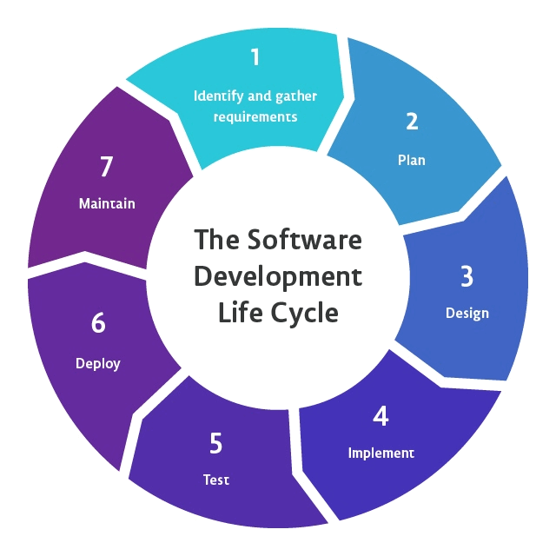

**Requirements**

* **Description**: Gathering detailed information from stakeholders to understand their needs.
* **Importance**: Ensures the project aligns with user expectations and business goals.
* **Interconnection**: Feeds into the feasibility study and design phases.

**Feasibility Study**

* **Description**: Assessing the practicality and viability of the project.
* **Importance**: Determines if the project is worth pursuing from technical, financial, and operational perspectives.
* **Interconnection**: Validates the requirements and sets the groundwork for design and planning.

**Design**

* **Description**: Creating architecture, user interfaces, and system components.
* **Importance**: Provides a blueprint for the system, guiding implementation and development.
* **Interconnection**: Uses feasibility study results and detailed requirements to design an effective solution.

**Implementation**

* **Description**: Coding and building the actual system based on design specifications.
* **Importance**: Translates design into a functional software product.
* **Interconnection**: Follows design guidelines and prepares the software for testing.

**Testing**

* **Description**: Verifying and validating the software to ensure it meets requirements and is free of defects.
* **Importance**: Ensures the quality, performance, and reliability of the software.
* **Interconnection**: Uses implemented software, feeding back into design and implementation for fixes.

**Deployment**

* **Description**: Releasing the software to the user environment.
* **Importance**: Makes the software available for use in a real-world setting.
* **Interconnection**: Ensures the transition from testing to operational use is smooth and coordinated.

**Maintenance**

* **Description**: Providing ongoing support and updates to the software.
* **Importance**: Ensures the software remains functional, secure, and relevant over time.
* **Interconnection**: Continuously interacts with all other phases to incorporate feedback, fix issues, and update features.